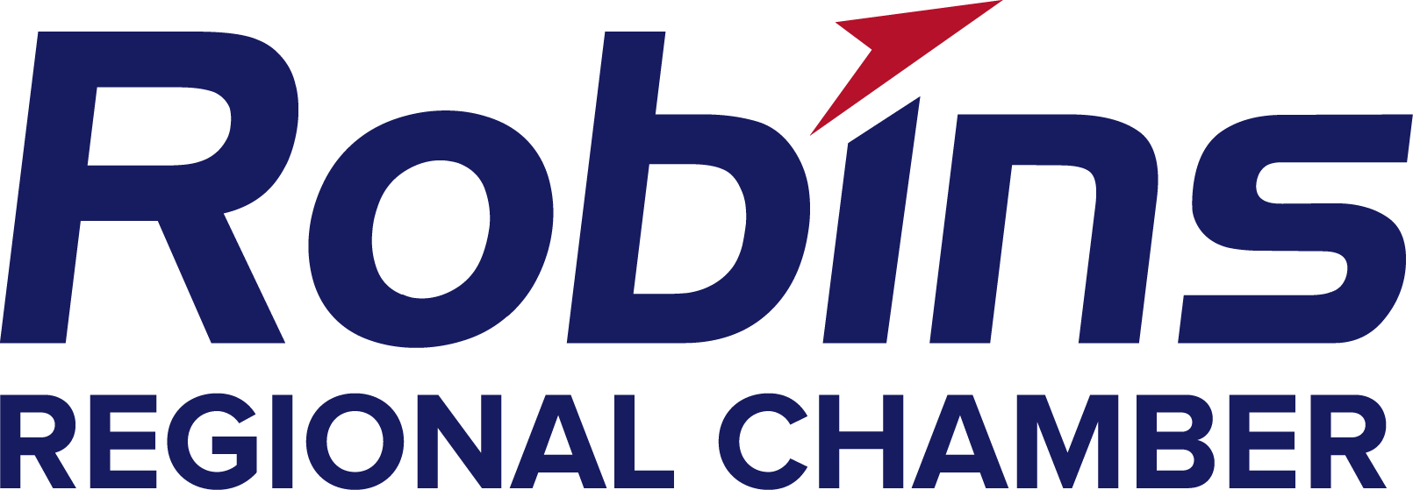p

Drugs Don’t Work Supervisor Training

I have read the attached information about substance abuse and the effects it has on individuals, their families, and the workplace. By reading and signing this form I have now completed ten minutes of the required two hours of employee training that I must receive during the year.
I understand that I must return this form within five workdays or no credit will be given towards my 2 hours of training. I also understand that failure to comply with this training is in violation of our Drug-Free Workplace Policy and may lead to my termination of employment, denial of unemployment benefits, and affect my right to obtain workers’ compensation benefits.

Return your signed form to your company’s Drugs Don’t Work Representative

Print Your Name: _____________________________________________

Sign Your Name: _____________________________________________

Date: __________________________

This form is provided by the Robins Regional Chamber’s Drug Free Workplace Support Center.
1228 Watson Boulevard, Warner Robins, Georgia 31093 (478) 922-8585
1-800-338-6745 Georgia Helpline/Alcohol & Drug Abuse Helpline

